Find Length of a Linked List (Iterative and Recursive)
Write a C function to count number of nodes in a given singly linked list.
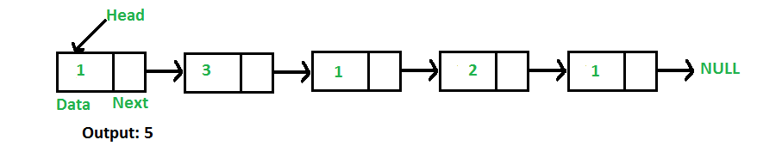
For example, the function should return 5 for linked list 1->3->1->2->1.
Iterative Solution
1) Initialize count as 0
2) Initialize a node pointer, current = head.
3) Do following while current is not NULL
a) current = current -> next
b) count++;
4) Return count
Following are C/C++, Java and Python implementations of above algorithm to find count of nodes.
- C/C++
- Java
- Python
// Java program to count number of nodes in a linked list

/* Linked list Node*/
class Node
{
int data;
Node next;
Node(int d) { data = d; next = null; }
}

// Linked List class
class LinkedList
{
Node head; // head of list

/* Inserts a new Node at front of the list. */
public void push(int new_data)
{
/* 1 & 2: Allocate the Node &
Put in the data*/
Node new_node = new Node(new_data);

/* 3. Make next of new Node as head */
new_node.next = head;

/* 4. Move the head to point to new Node */
head = new_node;
}

/* Returns count of nodes in linked list */
public int getCount()
{
Node temp = head;
int count = 0;
while (temp != null)
{
count++;
temp = temp.next;
}
return count;
}

/* Drier program to test above functions. Ideally
this function should be in a separate user class.
It is kept here to keep code compact */
public static void main(String[] args)
{
/* Start with the empty list */
LinkedList llist = new LinkedList();
llist.push(1);
llist.push(3);
llist.push(1);
llist.push(2);
llist.push(1);

System.out.println("Count of nodes is " +
llist.getCount());
}
}

